**Section 1–3: Algebraic Expressions**

**Dictionary: how to speak mathematics?**

Here are some words associated with **addition**: add, plus, together, sum, total, and, etc…

Here are some words associated with **subtraction**: minus, subtract, less, fewer, difference, etc…

Here are some words associated with **multiplication**: multiply, times, product, etc…

Here are some words associated with **division**: divided, quotient, ratio, etc…

**Example 1: Modeling Words with an Algebraic Expression**

What is the algebraic expression model for the word phrase *two times the sum of a and b*?

**Question 1:** How many variables are there?

Two, *a* and *b*.

**Question 2:** How many types of operation are we dealing with?

Two, addition and multiplication.

**Tip 1:** You should know for most of the time (not always, approximately 95%) the word phrase matches the algebraic expression model literally from left to right. Therefore, you can at least set-up the numbers and variables first before placing the operation signs into the algebraic expression model.

Your algebraic expression model should look something like this: $2$ $a$ $b$

The gaps between the numbers and variables are where you place the operation signs. We know by the word phrase “*the sum of a and b*” that the plus sign (+) must be between *a* and *b*.

Your algebraic expression model should now look something like this: $2$ $a+b$

What about “*two times the sum of a and b*”? Well, you need to place the multiplication sign before $a+b$. However, there are few different signs represent multiplication: $×, ∙ , \left(\right)$. You need to choose wisely of which one to use. If you use the signs incorrectly, then your word phrase would change too.

Incorrect Signs: $2×a+b$ or $2∙a+b$ means *the sum of 2 times a and b*

**Correct Sign: $2(a+b)$ means *two times the sum of a and b***

**Example 2: Modeling a Situation**

You had $150, but you are spending $2 each day. What algebraic expression models this situation?

To model a situation with an algebraic expression, do the following steps:

Step 1: identify the actions that suggest operations.

Step 2: define one or more variables to represent the unknown(s).

Step 3: represent the actions using the variables and the operations.

Step 1: **Starting Amount** minus **Amount Spend** times **Number of Days**

Step 2: Let $d$ = the number of days.

Step 3: $150 - 2 ∙ d$

The expression $150-2d$ models the situation.

**Example 3: Evaluating Algebraic Expressions**

To **evaluate** an algebraic expression, substitute a number for each variable in the expression. Then simplify using the order of operations.

**EVALUTE = SOLVE**

What is the value of the expression for the given values of the variables?

$\frac{2(x^{2}-y^{2})}{3}$ for *x* = 6 and *y* = –3

$\frac{2(6^{2}-{(-3)}^{2})}{3}$ Substitute the value for each variable and simplify the power.

$=\frac{2(36-9)}{3}$ Perform operations within grouping symbols.

$=\frac{2(27)}{3}$ Multiply.

$=\frac{54}{3}$ Divide.

$=18$

An expression that is a number, a variable, or the product of a number and one or more variables is a **term**. A **coefficient** is the numerical factor of a term. A **constant term** is a term with no variables. You can add terms to form longer expressions. The expression below has three terms.

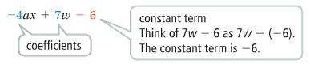

**Like terms** have the same variables raised to the same powers.

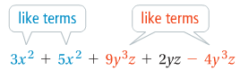

You can simplify an algebraic expression that has like terms. You combine like terms using the properties of real numbers. An expression and its simplified form are equivalent. Their values are equal for all values of their variables.

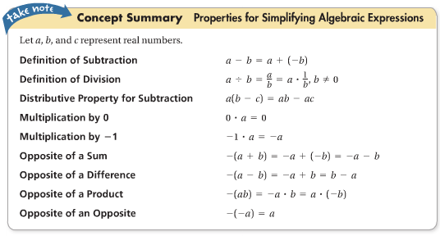

**Example 4: Simplifying Algebraic Expressions**

Combine like terms. What is a simpler form of each expression?

$$-\left(8a+3b\right)+10(2a-5b)$$

$-\left(8a+3b\right)+10(2a-5b)$ Identify like terms; opposite of a Sum and Distributive Property

$=-8a-3b+20a-50b$ Combine like terms.

$$=12a-53b$$